# ACTIVITY 2 - Sentiment Value and Star Ratings

Now that you have read several reviews and started exploring the sentimentVal

method, you will use this method to determine the overall sentiment of an entire review.

* Pick a review of your choice. Copy and paste the content of the review into a new text file that you create using a text editor, making sure to save the file with a .txt extension.
* If time permits, do this with multiple reviews. For testing purposes, you may also want to create a SimpleReview.txt file like the following:

This was a terrible restaurant! The pizza crust was too chewy, and I disliked the pasta. I would definitely not come back.

**Tip**

Strings are objects and have methods that can access information about them and create new strings. The course framework describes those methods which are part of the course, such as length, indexOf, and substring.

In the Review.java file:

1. Write the following method that determines the sentiment value of a review. Utilize the existing textToString method to complete the implementation of this method.

**public static double totalSentiment(String fileName)**

|  |
| --- |

**Tip**

When calling the String methods within the framework, such as indexOf and substring, adjustments must be made to account for strings being indexed starting at zero.

1. Test the method by calling totalSentiment(“SimpleReview.txt”)and printing the returned value.

|  |
| --- |

1. Write the following method that determines the star rating of a review.

**public static int starRating(String fileName)**

|  |
| --- |

**Tip**

To provide instructions for the computer to process many different input values, selection statements may need to be nested together to form more than two branches and options. Pathways can be broken down into a series of individual selection statements based on the conditions that need to be checked and nesting together the conditions that should only be checked when other conditions fail or succeed.

Sample Code:

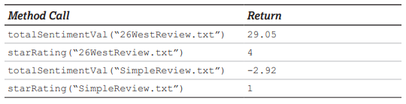

## **Check Your Understanding**

1. Explain how the totalSentiment method works, including how you’re using strings and iteration in your solution.

|  |
| --- |

1. Test your starRating method for multiple reviews, including your simple sample review.
   1. Do the ratings make sense? Explain why or why not.

|  |
| --- |

* 1. Describe at least two ways in which you could adjust your totalSentiment method so that your program returns even more reasonable ratings.

|  |
| --- |

A student is writing a starRating method based on his totalSentiment method, which calculates the sum of all of the sentiment values in a review. He comes up with the following:

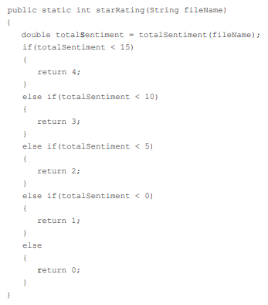

1. Explain to the student, using specific examples of (a) what logical error he made in writing his code, and (b) how to fix it.

|  |
| --- |